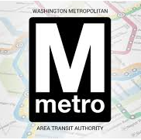
Bus
Fare
Evasion
Project

PROBLEM: WMATA loses approximately 10 to 20 million dollars per year on bus fare evasion.
- DATA DISCOVERY: Does this happen on specific routes/stops/time of day? Can we construct demographic profiles of fare evaders? Does faulty equipment and the driver contribute to the fare loss?
- LITERATURE REVIEW: What have other transit companies done to stop bus fare evasion? Can we make recommendations to WMATA?
What will you be expected to do?
- Lots of data profiling, preparation, and exploration (in R) using the SDAL data framework.
- Link WMATA data sources: SmarTrip Cards, fare box, bus, and any other data sources.
- Field trips to WMATA facilities to learn how fare boxes work and taking bus trips.
- Review the mass transit literature for how other companies address fare evasion, what works and what doesn’t, and writing up the findings.
- Lots of exploratory data analysis to tell the story of fare evasion prevalence on the 325 bus routes over all bus stops and duration of operation [in R].
- Write up the findings, construct a poster, and present the findings to WMATA.
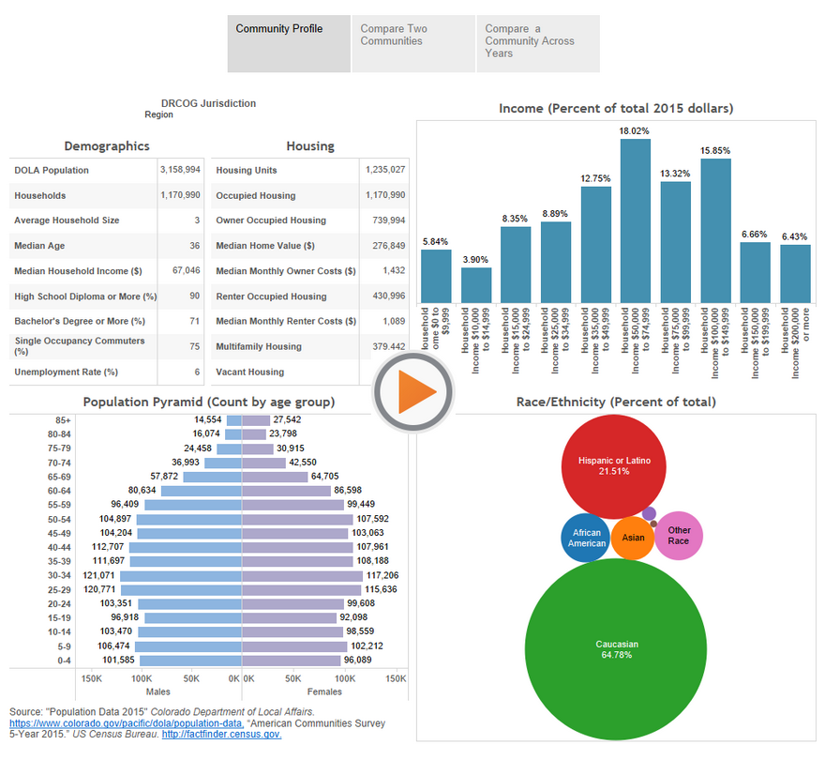
Community
Profiles &
Composite
Indicators

GOAL: Tell the story of a “community” using designed, administrative, opportunistic, and procedural data sources.
- DATA DISCOVERY: What data sources are available on the Internet at different observational units, county/city and smaller units such as census block groups, school districts, neighborhoods, etc.?
- COMMUNITY PROFILE: Use these data sources to construct community profiles and composite indicators, that provide insight into the quality-of-life of a community.
This is a group project. Everyone will sign up to work on a community profile that will be used to address an issue for a county/city in VA: Fairfax, Arlington, New Kent, Roanoke, and Alexandria. The issues of interest are:

- ALEXANDRIA: what is the state of racial & socio-economic equity?
- ARLINGTON: who are using their services, what additional services are needed;
- FAIRFAX: forecast how changes in population size are impacting youth behavior.
- NEW KENT: the county is growing what services are needed for the elderly & young residents?
- ROANOKE: who are their vulnerable populations, for example refugees?

What will you be expected to do?
- Search the Internet for available data sources, store the data sources, and process them using the SDAL data framework.
- Create a catalog of available data sources that would include: source of the data, a list of variables, observational unit(s), geographic area covered, how often the data are updated, etc.
- Use the data sources to address specific county/city issues.
- Field trips with local officials to discuss issues.
- Create a directory of academic articles and websites with information on community indicators, along with a list of the communities using indicators.
- Write up the findings, present to local leaders, and construct a poster.

Arlington

The following questions will help direct the data discovery process – needs assessment for various populations:
- What childcare services are available to low income residents for children ages 0-5 years?
- What summer childcare services are there for low income families?
- What do low income middle school children go after school, what programs are available to them?
- What library services would better serve the elderly and immigrant populations?

